Health AI: Intelligent HealthCare Assistant

**Project Documentation**

**1.introduction**

* **Project title: Health AI: Intelligent Healthcare Assistant**
* **Team member: P. Barathi**
* **Team member: R. Jeevitha**
* **Team member: V. Devipriya**
* **Team member: J. Abirami**

**1. Project Overview**

**Health AI – Intelligent Healthcare Assistant (IHA) is an advanced artificial intelligence-powered solution designed to assist healthcare providers and patients by offering personalized health guidance, monitoring, and support. The system leverages machine learning, natural language processing, and real-time data analytics to enhance the efficiency, accessibility, and quality of healthcare delivery.**

**Purpose**

* **Improve patient outcomes through early diagnosis and monitoring.**
* **Reduce healthcare costs by minimizing unnecessary hospital visits.**
* **Support healthcare professionals in decision-making.**
* **Provide continuous health tracking and personalized care.**

**2. System Architecture**

**2.1 Core Components**

**1.User Interface (UI)**

* **Web or mobile application for patient interaction.**
* **Dashboard for healthcare providers to monitor patient health.**

**2.AI Engine**

* **Symptom checker using machine learning models.**
* **Predictive analytics for disease risk assessment.**
* **Natural language understanding for conversation flow.**
* **Data Management Layer**
* **Secure data storage in cloud infrastructure.**
* **Real-time data processing from IoT devices and wearables.**

**4.Integration Layer**

* **APIs to connect with electronic health records (EHR), lab reports, and other health services.**

**3. Features**

**3.1 Patient-Facing Features**

* **Symptom Analysis: Provides probable conditions based on symptoms.**
* **Virtual Health Assistant: Answers common medical queries.**
* **Medication Reminders: Sends alerts for scheduled medicines.**
* **Chronic Disease Monitoring: Tracks patient vitals and provides reports.**
* **Mental Health Tools: Offers exercises and coping strategies.**

**3.2 Doctor-Facing Features**

* **Clinical Decision Support: Offers treatment recommendations.**
* **Patient Monitoring Dashboard: Displays vital signs and alerts.**
* **Predictive Alerts: Flags critical conditions in advance.**
* **Data Analytics Reports: Provides insights based on patient history.**

**4. Technology Stack**

|  |  |
| --- | --- |
| **Layer** | **Technology/tool** |
| **AI/ML Engine** | **Python, TensorFlow , PyTorch** |
| **NLP** | **SpaCy, BERT, GPT-based APIs** |
| **Data Storage** | **AWS S3, Azure Blob Storage** |
| **Data Processing** | **Apache Kafka, Spark** |
| **Could Platform** | **AWS, Google Could, Azure** |
| **Security** | **SSL encryption, OAuth 2.0** |
| **Fronted** | **React Native, Flutter** |
| **Backend** | **Node. js, Django, Flask** |

**5. Data Flow Diagram**

* **Patient enters symptoms →**
* **Data transmitted securely →**
* **AI engine analyzes and checks databases →**
* **Suggested actions or medical advice sent →**
* **Alerts or reports delivered in real-time.**

**6. User Roles and Access**

|  |  |
| --- | --- |
| **Role** | **Permissions** |
| **Patient** | **View dashboard, receive alerts, chat with assistant** |
| **Doctor** | **Access patient records, receive notifications, suggest treatments** |
| **Admin** | **Manage system settings, monitor overall performance** |
| **Data Analyst** | **View anonymized reports for research and insights** |

**7. Security & Privacy**

* **All patient data is encrypted during storage and transmission.**
* **Multi-factor authentication is enforced for accessing sensitive information.**
* **Compliant with HIPAA, GDPR, and other healthcare regulations.**
* **Audit trails are maintained for tracking data access and modifications.**
* **Patients can opt-out of data sharing where applicable.**

**8. Challenges & Mitigations**

|  |  |
| --- | --- |
| **Challenge** | **Mitigation Strategy** |
| **Data Privacy** | **End-to-end encryption, consent-based data usage** |
| **Model Bias** | **Use diverse datasets, continuous retraining, and human oversight** |
| **User Trust Transparent** | **Transparent recommendations, explainable AI reports** |
| **Integration** | **API documentation, compliance with healthcare standards** |

**9. Future Enhancements**

* **Incorporation of genomic data for precision medicine.**
* **Expansion into surgical robotics and AI-assisted diagnostics.**
* **Improved voice-based interfaces for accessibility.**
* **Integration with insurance and billing systems.**
* **Real-time health crisis prediction using IoT and wearable devices.**

**10. Conclusion**

**The Health AI – Intelligent Healthcare Assistant is a transformative tool aimed at empowering patients and healthcare providers with AI-driven insights, personalized care, and improved health monitoring. It offers a scalable and secure solution for modern healthcare challenges, ensuring better health outcomes, cost efficiency, and enhanced accessibility.**

**If needed, I can format this into a PDF, slide deck, or developer manual. Let me know how you want to proceed.**

**11. screen shorts**

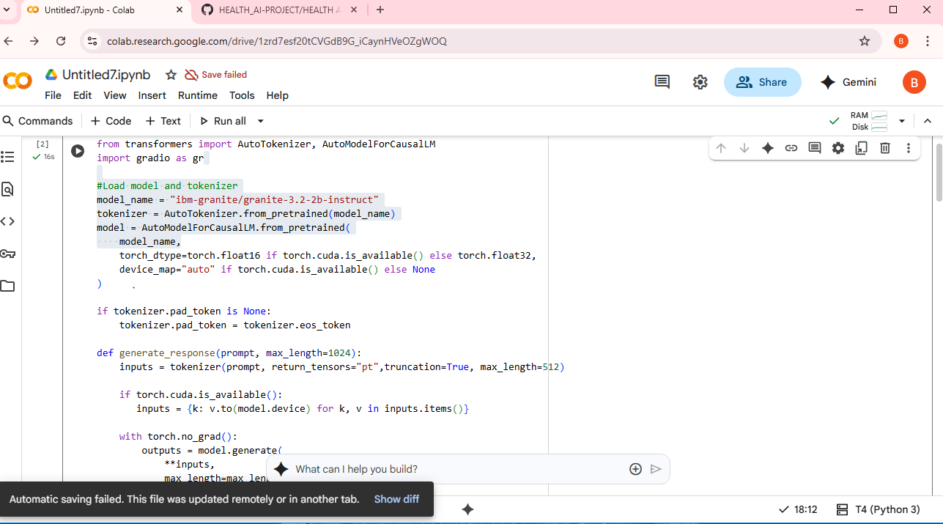

**12.Known Issues in the Medical AI Assistant Code**

I've mentioned these before, but here's a recap of the known issues in the code:

**1. Typos and incorrect names:**

- from_pertrained should be from_pretrained.

- AutomodelforcauusalLM should be AutoModelForCausalLM**.**

- gr.TabItem should be gr.Tab.

- lable should be label.

- mx_length should be max_length.

- genter should be gender.

**2. Potential logical issues:**

- input item should likely be inputs.items() in the generate_response function.

- inputs is used in model.generate(**inputs, ...), but input is defined earlier.